**EMT 2433: DESIGN OF MECHATRONIC SYSTEMS 1**

**GROUP MEMBERS**

**JUMA JOEL MWIMALI ENM221-0060/2017**

**ERICK KIPNG’ENO ENM221-0068/2017**

**Design of a Used Oil Furnace with Variable Temperature**

2021

**Table of contents**

List of figures iii

1 Chapter 1 1

1.1 INTRODUCTION 1

2 Chapter 2 2

2.1 LITERATURE REVIEW 2

2.1.1 Conventional Oil Furnaces 2

2.1.1.1 Burner 2

2.1.1.2 Nozzle 2

2.1.1.3 Ignition 2

2.1.1.4 Emission 2

2.1.1.5 Oil Consumption 2

3 Chapter 3 3

3.1 DESIGN METHODOLOGY 3

3.1.1 High-pressure cylinder design calculations 3

3.1.1.1 Thickness 3

3.1.1.1.1 Clavarino’s Equation 3

3.1.1.2 Material 4

3.1.1.3 Computing the ultimate thickness 4

3.1.2 Heating coil 8

3.1.2.1 Calculations: 8

3.1.2.2 Material 10

3.1.3 Atomizer 11

3.1.3.1 Coaxial Swirl Injector 11

3.1.3.1.1 Design 12

3.1.4 Burner 13

4 Chapter 4 14

4.1 RESULTS 14

4.1.1 High-pressure cylinder 14

4.1.2 Heating coil 14

4.1.3 Coil tube 15

4.1.4 Burner 15

4.1.5 Coaxial swirl injector 16

4.1.5.1 Assembly and Fabrication of the coaxial swirl injector 16

4.1.5.1.1 Swirl Assembly 17

4.1.5.1.2 Baseplate 19

4.1.5.1.3 Separator plate 20

4.1.6 Assembly 22

4.1.6.1 Working principle 22

5 Chapter 5 24

5.1 CONCLUSION 24

References 25

# List of figures

Figure 3‑1: Thickness against Internal pressure 7

Figure 3‑2: Actual dimensions of the cylinder 7

Figure 3‑3: Coaxial Swirl Injector 11

Figure 4‑1: Cylinder 14

Figure 4‑2: Heating coil 14

Figure 4‑3: Oil tube 15

Figure 4‑4: Burner 15

Figure 4‑5: Coaxial swirl injector 16

Figure 4‑6: Swirl Injector Exploded View 16

Figure 4‑7: Cross-section of the assembly 17

Figure 4‑8: Cap Machining 18

Figure 4‑9: Inner element of the swirler 18

Figure 4‑10: Outer element of the swirler 19

Figure 4‑11: Base plate machining 19

Figure 4‑12: Base Plate total operations 20

Figure 4‑13: Separator Plate Stock setup 20

Figure 4‑14: Stock Plate Machining Instructions 21

Figure 4‑15: Process flow chart 22

# Chapter 1

## INTRODUCTION

Oil has the benefit of never wearing out – it can be cleaned and reused many times. In other words – it can be recycled. The [process for recycling waste oil](http://www.greenlivingtips.com/articles/recycling-used-engine-oil.html) includes water extraction, filtering, de-asphalting, and distillation. Oil can then be reused in a motorized equipment, turned into hydraulic oil, or used to make plastics. Another way to use waste oil efficiently is burning it in a furnace for heat. Burning oil in a conventional furnace is inefficient, since oil requires extra design considerations to ensure high burning efficiency by limiting heat losses and maximizing heat generation.

Used Oil-fired furnaces have been around for a long time, but little has been done to ensure that these furnaces operate with the highest efficiency possible. Most of these furnaces are operated manually, putting the operators at risk in case of explosions or toxic gas exposure. They are also operated at single specific temperatures with no room for adjustment if needed. In recent years, there have been numerous attempts to address this issue, but these efforts have not yielded any significant results.

The aim of this project aims to design a used oil furnace using mechatronic approach such that oil flow and pressure is automatically controlled, ignition is automatic, oil is pressurized automatically, oil is preheated before burning, the system will adjust automatically to any set temperature, and that the burner material will last relatively longer.

# Chapter 2

## LITERATURE REVIEW

### Conventional Oil Furnaces

#### Burner

Conventional designs of the burner do not gather for its maintainability. Such burners are designed as a single solid attached to the nozzle. Since most furnaces operate at temperatures more than 18000C, such burners burn out and become non-functional after some few operations. Due to such solid design of such furnaces, replacements of such parts require overhauling. The choice of material plays a role in the frequency of maintenance.

#### Nozzle

Most designs use separate nozzles for pressurized air and oil. Such a design has proven to be inefficient since smoke emissions are frequently witnessed. It also introduces complexity in the design since the pressurized air nozzle has to be placed at a precisely measured distance from the pressurized oil nozzle, and this might not always be accurate.

#### Ignition

Ignition for conventional oil furnaces employs a flammable hydrocarbon plastic mounted on an insulator or even soaked in a highly flammable petroleum fuel. This method is unsafe since its control is limited. The use of highly flammable petroleum fuel for ignition also makes it expensive and borderline dangerous.

#### Emission

Combustion of oil in a good proportion of oxygen produces carbon dioxide. During oxygen deficiency, carbon monoxide is released. If not detected and controlled such gases can be catastrophic. Since such emissions are invisible, conventional designs of this type of furnace do not gather for such hazards.

#### Oil Consumption

Conventional designs are based on the workability of the design. Its efficiency is rather given very minimal attention. The use of separate nozzles for the pressurized oil and air undermines the efficiency of the design. As such, the consumption of oil is rather higher

# Chapter 3

## DESIGN METHODOLOGY

Our proposed design will incorporate the following parts: the high-pressure cylinder, the burner, the heating coils, coil tubes together with heating coils.

### High-pressure cylinder design calculations

#### Thickness

This cylinder was designed to have to have the following dimensions:

Length: 3m

Internal Diameter: 800mm

The thickness of the cylinder has to be chosen carefully to achieve a recommended factor of safety for pressure vessels between 3 and 6. To determine that, Clavarino’s equation is preferred to Lame’s equation since the cylinder is closed at both ends as shown in *figure 1.1*.

##### Clavarino’s Equation

Clavarino’s equation is used to determine the wall thickness of a cylinder. This equation applies to cylinders with closed ends made of ductile materials. It is based on the maximum principal strain theory.



Where:

P is the internal pressure, N/m2

D is the internal diameter, m

S is the allowable tensile stress, N/m2

t is the thickness of the material shell, m

µ is the poison’s ratio

#### Material

The material of the cylinder is chosen to meet the following objectives:

1. The material should be light (weight). This allows for bigger sizes without the limit of weight.
2. It should be less rusty.
3. Carbon content should not exceed 1/8 of its total mass

The above objectives narrow down the search of the material to Carbon fiber or Fiber Glass. The amount of carbon in carbon fiber makes it a lesser attractive choice as compared to Fiber Glass even though it has a higher ultimate tensile strength. Fiber Glass is therefore chosen for the design of the cylinder.

Standard fiberglass has the following properties:

1. Ultimate tensile strength 1950-2000Mpa
2. Poisson’s ration 0.23

#### Computing the ultimate thickness

To compute the ultimate thickness of the cylinder, the value of internal pressure of the cylinder can be assumed and the thickness computed. This method involves several guesses to obtain an ultimate internal pressure for a factor of safety of between 3 and 6.

Instead, a MATLAB script can be written to compute the ultimate internal pressure and thickness for a factor of safety between 3 and 6. The script is shown below:

clc

clear

p_fos**=**3**;**% recommended factor of safety for pressure vessels is between 3.0 - 6.0

D **=**800**;**% internal diameter 800mm

S **=**1950**\***10**^**6**;**% Ultimate tensile strength for Fiberglass

u **=**0.23**;**% poissons ratio for fiber glass

t **=[**0**,**0.001**];**% 1000th of a meter starting thickness

P **=[**0**,**0**];**

figure**(**1**);**

plot**(**P**,**t**,**"x"**);**

i**=**2**;**

**while(**1**)**

i**=** i**+**1**;**

% internal pressure

P**(**i**)=(**S**\*((((**2**\***t**(**i**-**1**)/**D**)+**1**)^**2**)-**1**))/((**1**-**2**\***u**)+(**1**+**u**)*(((**2**\***t**(**i**-**1**)/**D**)+**1**)^**2**));**

t_fos**=** S**/**P**(**i**);**% factor of safety(fos)

% if fos is below the recommended value,break

**if(**t_fos**<**p_fos**)**

**break**

**end**

hold on

t**(**i**)=** t**(**i**-**1**)+**0.01**;**% 0.01 increment thickness

plot**(**P**(**1**:**i**),**t**(**1**:**i**),**"x"**);**

**end**

title**(**"Thickness against Internal Pressure"**)**

ylabel**(**"Thickness(m)"**);**

xlabel**(**"Pressure(Pa)"**)**

legend**(**"Shell Thickness vs internal pressure"**)**

hold off

This script, however, has a downside. The simulation involves computing more than 10,000 values for only a factor of safety below 30. MATLAB is super slow for this kind of computation.

An alternative C++ script can be written to speed up the computation. This is as shown below.

#include "matplotlibcpp.h"

#include <cmath>

**namespace**plt**=**matplotlibcpp**;**

int main**(){**

// declare constants

constintp_fos**=**3**;**// recommended factor of safety for pressure vessels is between 3.0 - 6.0

constint D **=**800**;**// internal diameter 800mm

constint S **=(**1950**\***std**::**pow**(**10**,**6**));**// Ultimate tensile strength for Fiber glass

constfloat u **=**0.23**;**// poissons ratio for fiber glass

// prepare the data

std**::**vector**<**double**>**t**,**P**;**

t**.**emplace_back**(**0.001**);**// 1000th starting thickness

P**.**emplace_back**(**0**);**// 0 starting pressure

**while(**1**){**

doubletemp **=(**S**\*(**std**::**pow**(((**2**\***t**.**back**()/**D**)+**1**),**2**)-**1**))/((**1**-**2**\***u**)+(**1**+**u**)\***std**::**pow**(((**2**\***t**.**back**()/**D**)+**1**),**2**));**

P**.**emplace_back**(**temp**);**

t**.**emplace_back**((**t**.**back**()+**0.1**));**// increment thickness by 0.01

float _fos**=(**S **/**P**.**back**());**// compute factor of safety

printf**(**"%f\n"**,**_fos**);**

**if(**_fos**<**3**){**

**break;**

**}**

**}**

printf**(**"Ultimate pressure: %f\n"**,**P**.**back**());**

plt**::**figure_size**(**1300**,**768**);**

plt**::**named_plot**(**"Thickness vs Internal pressure"**,**P**,**t**);**

plt**::**title**(**"Thickness Vs Internal pressure"**);**

plt**::**legend**();**

plt**::**show**();**

**}**

The script computes both the internal pressure and factor of safety with varying thickness and stops when the factor of safety goes below 3. It then plots the relationship between the thickness of the cylinder shell and the internal pressure. The plot is as shown in *Figure 3‑1*below.

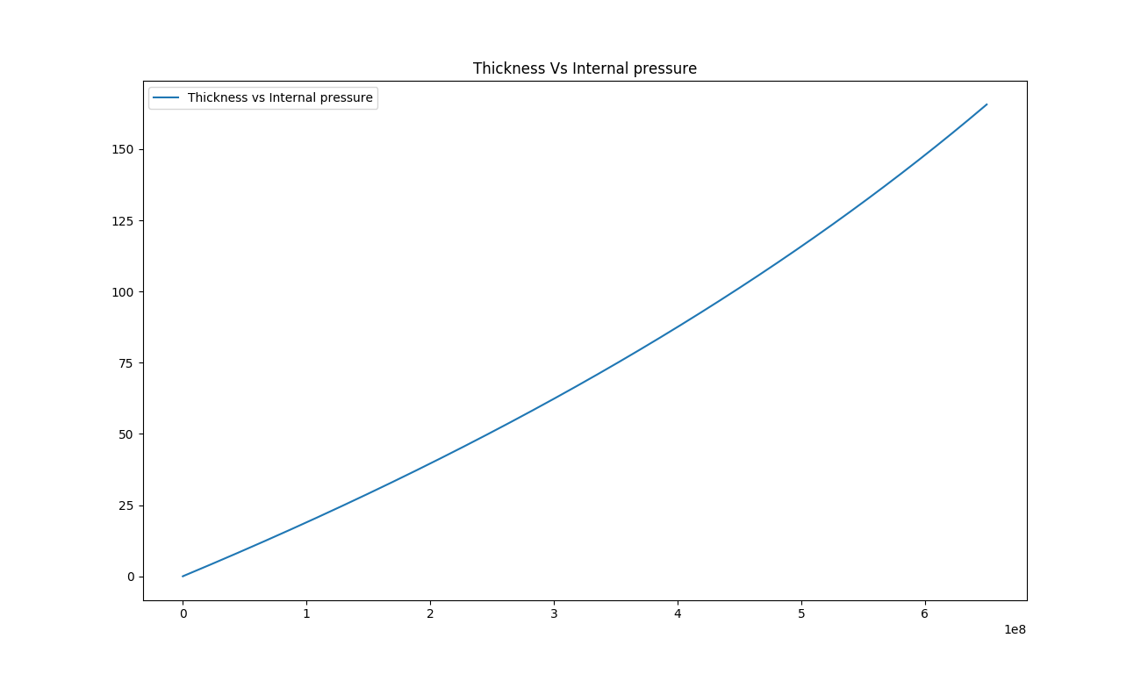

Figure 3‑1: Thickness against Internal pressure

This shows that the relationship between the internal pressure and the thickness of the cylinder is linear. From the computation, it is also obtained that the internal pressure of the cylinder for a factor of safety 3 is 650.042MPa. and the corresponding thickness is 42.075mm as shown *Figure 3‑2*below:

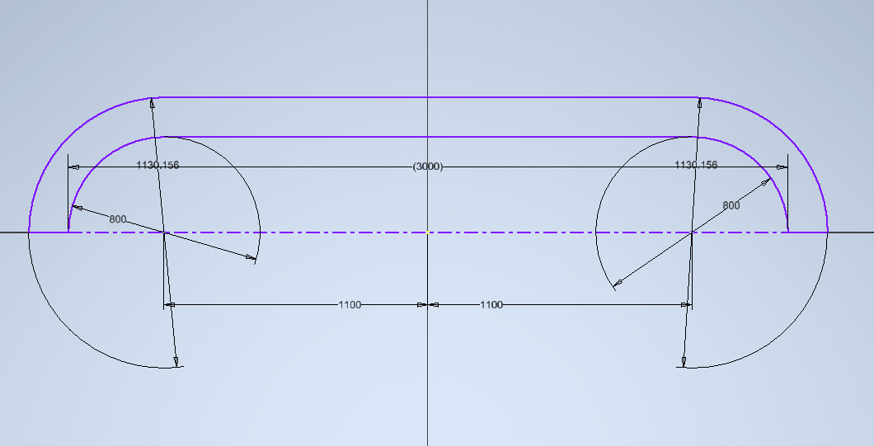

Figure 3‑2: Actual dimensions of the cylinder

### Heating coil

The design the heating element is such the high pressure pipe conveying oil from the tank is coiled at some approximate distance from the nozzle and passed through a coiled electric heating element to preheat oil before the nozzle. Such coil design is meant to ensure minimum heat loss during such heating process.

Notations:

V = Voltage (Volts)

W = Power (Watts)

S = Surface area loading (W/cm2)

Rt =Element Resistance at operating temperature (Ohms)

R = Element resistance at 200C

F = Temperature resistance factor

L = Length of the wire (m)

A = resistance per meter (Ohms/m)

#### Calculations:

To calculate the wire diameter and length required for a 750w/240v tube, operating at a maximum temperature of 1100°C, the total resistance of the element at operating temperature (Rt) will be:

$$R_{t}=\frac{V^{2}}{W}$$

= $\frac{{240}^{2}}{750}=76.8 Ohms$

Using [specific heating element alloy wire](https://www.jlcelectromet.com/nickel-chromium-heating-resistance-alloy-grades.html), find the Temperature Resistance Factor at C°C operating temperature as F thus the total resistance of the element at 20°C (R) will be.

$$R_{t}=\frac{R_{t}}{F}$$

Using RW80 wire, the [Temperature Resistance Factor (F)](https://www.alloywire.co.za/electrical-resistance-wire-hot-cutting-wire/heating-element-design/overview-heating-element-design-calculation/) at 1100°C is 1.071 thus the total resistance of the element at 20°C (R) will be:

$$R_{t}=\frac{76.8}{1.071}=71.71 Ohms$$

With the dimensions of the tube, the length of wire that may be wound around it may be estimated.  Thus, the resistance required per meter of wire will be:

For example a length of wire of 9 meters

$$A=\frac{R}{L}$$

= $\frac{71.71}{9}=7.97Ohms/m$

Find the [heating element wire of standard wire diameter](https://www.jlcelectromet.com/fecral-heating-resistance-alloy-grades.html) which has a resistance per meter which is closest to A.

 RW80 of wire diameter 0.417mm has a resistance per meter of 7.91 ohms/m which is closest to 7.97 ohms/m.

The actual wire length (L):

$$L=\frac{R}{A}$$

= $\frac{71.71}{7.91}=9.066m$

A change in [heating element wire length](https://www.jlcelectromet.com/fecral-heating-resistance-alloy-grades.html)may mean adding or subtracting the pitch of the wire to achieve the total resistance value required.

The surface area loading (S):

$$S=\frac{W}{l*d*31.416}$$

= $\frac{750}{7.066*0.417*31.416}=6.31W/cm2$

The surface area loading can be higher or lower if it is considered the heat transfer be better or worse, or depending upon the importance of the [heating elements life](https://www.jlcelectromet.com/fecral-heating-resistance-alloy-grades.html).

Therefore, for the design of a heating coil to handle 750w and 240V working over a length of 9m, then from our analysis the coil has to have a total resistance of 71.71 Ohms with a surface are loading of 6.31W/cm2. Besides, the coil should have a diameter of 0.147mm for maximum heat transfer.

#### Material

The choice of material for the heating coil is such that it meets the following objectives.

1. High electrical resistance
2. Corrosion resistance at high temperatures
3. High melting points

Based on the above objectives the most viable choice is an alloy of nickel and chromium. Nickel Chromium has a percentage of nickel and chromium combined. The addition of chromium provides an increase of electrical resistance as well as corrosion resistance to high temperatures, making the alloy appropriate for wound wire elements due to its ductility and strength. This alloy has a maximum operating temperature of 1100°C and a heat capacity of about 20°C.

### Atomizer

An atomizer is required to deliver the pressurized oil under high pressure to the combustion unit in the tiniest sprays possible. There are three viable designs for the atomizer: coaxial swirl injector, pintle injector, and self-impinging injector. From the abovedesigns, the coaxial swirl injector was selected due to its ease of fabrication compared to the pintle injector and self-impinging injector. The injections are expected to deliver the pressurized oil with ideal flow characteristics and atomize the fuel adequately.

#### Coaxial Swirl Injector

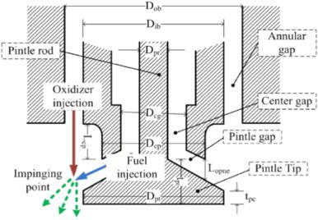

Figure 3‑3: Coaxial Swirl Injector

A coaxial swirl injector performs the primary function of feeding oil to the combustion chamber. The design of this injector for oil furnace meets the following functional requirements;

1. The oil injector must be able to inject oil into the combustion chamber at the correct ratio and correct flow rates. For this reason, the discharge coefficient of the injector must be determinable.
2. The oil injector should ensure complete mixing of oil with air to avoid undesired combustion with might result in the emission of carbon monoxide.
3. The oil injector must facilitate a primary pressure drop of between 10-20% to prevent discharged oil from flowing back into the injection system and causing an explosion.

##### Design

This swirl injector will consist of two primary parts; the inner element and the outer element. The two elements are placed on different levels separated by a separator plate. The inner element takes in pressurized oil tangentially which causes the liquid to swirl along the wall of the inner section. The pressurized oil enters the outer section tangentially as well and swirls along the wall of the outer element. This results in the pressurized air leaving the inner element in the shape of a cone that collides with the cone formed by the outer element. In this way, the pressurized oil and pressurized air each leave each of the elements in a cylindrical manner colliding and atomizing due to the high pressure and velocity of the flow.

This configuration meets the functional requirements of any fuel injector system.The efficiency of the injector for oil of any density can reach as high as 95%. The swirl injector has the following advantages;

1. The design is highly scalable since the assembly can be made bigger by adding the number of swirl elements in the assembly.
2. The swirl and assembly are relatively easy to machine
3. The swirl offers high atomization which is crucial for the conversion of chemical energy to thermal energy
4. The swirl element offers adjustable flow parameters allowing the assembly to create oxygen-rich zones and oil-rich zones.
5. Swirl elements offer the ability to vary the velocity of the fuel which can enhance the mixing of the pressurized air and pressurized oil.

The disadvantages of swirl injectors are:

1. They are a relatively new type of injector with fewer developed optimization characteristics
2. They require high dimensional accuracy for high performance

The other types of injector designs considered were;

### Burner

The materials chosen for the manufacture of these burners are made from silicon carbide. This is so since silicon carbide has high heating temperature, high-temperature resistance, oxidation resistance, corrosion resistance, and long service life. Besides, it has the characteristics of fast heating, small high-temperature deformations, convenient installation and maintenance, and has good chemical stability. It is convenient, safe, and reliable to use the silicon carbide rod for heating. The resistance is accurate and adopts Secondary resistance measurement; resistance error is small. The silicon carbide rod has high density, strong conductivity, fast heating, low power consumption, thereby saving energy and reducing consumption, and reducing production costs.

# Chapter 4

## RESULTS

Based on our design consideration, parameters computation, and from the above calculations we came up with the following conceptual designs in Autodesk Inventor 2021.

### High-pressure cylinder

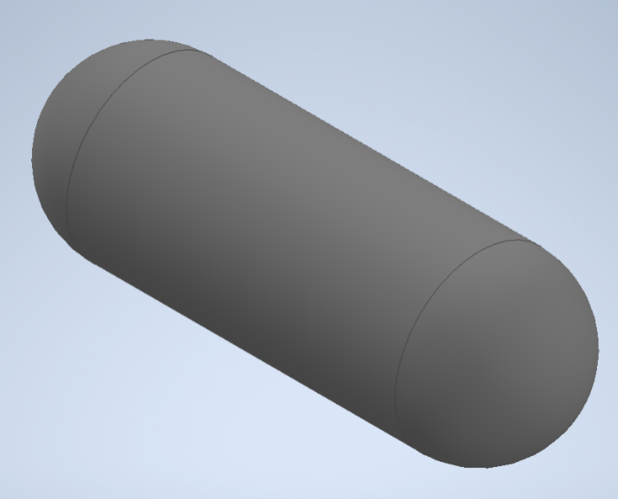

Figure 4‑1: Cylinder

### Heating coil

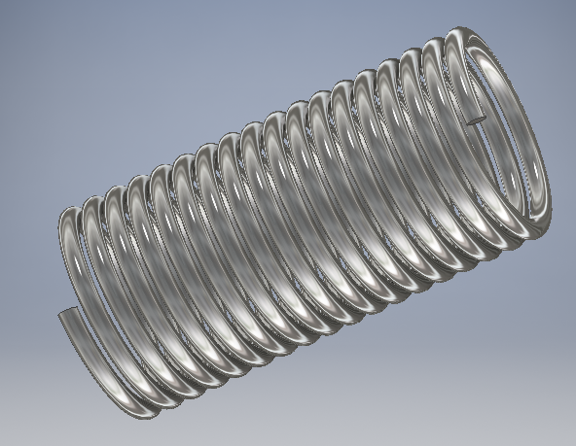

Figure 4‑2: Heating coil

### Coil tube

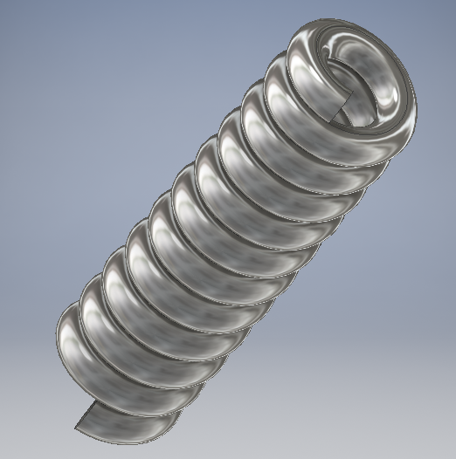

Figure 4‑3: Oil tube

### Burner

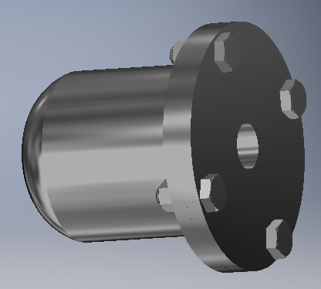

Figure 4‑4: Burner

### Coaxial swirl injector

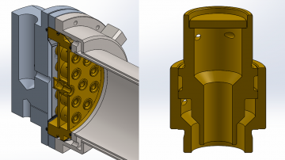

Figure 4‑5: Coaxial swirl injector

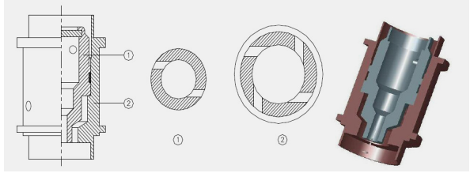

Figure 4‑6: Swirl Injector Exploded View

#### Assembly and Fabrication of the coaxial swirl injector

The development of the design was done by separating the assembly into five distinct parts:

1. Separator plate
2. Baseplate
3. Swirler cap
4. Inner swirl element
5. Outer swirler element

##### Swirl Assembly

The parts were drawn on Autodesk Inventor for the 3D representation. The individual parts were then assembled. A cross-section of the assembly is shown below.

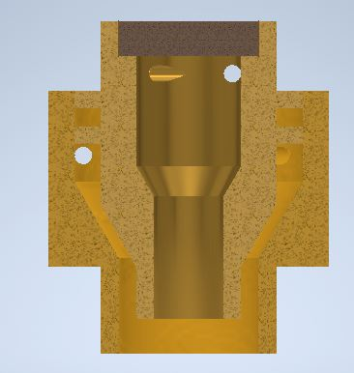

Figure 4‑7: Cross-section of the assembly

MasterCAMwas then used to demonstrate the fabrication processes.

The cap was machined using a CNC lathe. The first process was facing the stock. This was followed by a rough surface turning on the outer diameter profile followed by a finishing process on the surface. The part was then cut off from the stock using a grooving tool. The tool paths are shown below:

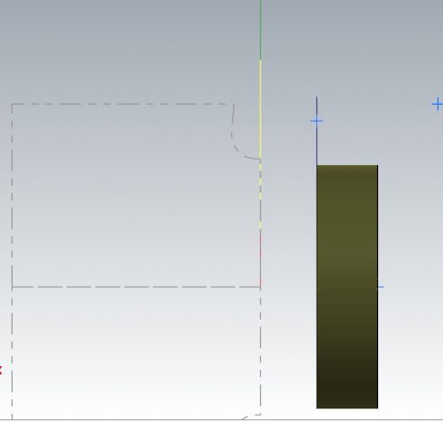

Figure 4‑8: Cap Machining

The inner element was machined using a CNC lathe. The first process was facing using a right-hand turning tool. A rough turning operation was then used to bring the dimensions to closer tolerance of the desired profile. A grooving operation was then used to machine the flanges on the profile. A grooving tool was also used to finish the tapered turning on the end of the part. A finishing turning operation was then done to bring the part to the required dimensions. A diameter 4 drill was then used to drill through the entire part. A diameter 8 drill was then used to a depth of 9mm. An internal grooving tool is then used to finalize the internal profile. The part was then cut off from the stock using a grooving tool. The holes were machined using a five-axis milling machine. below show some of the generated tool paths.

~~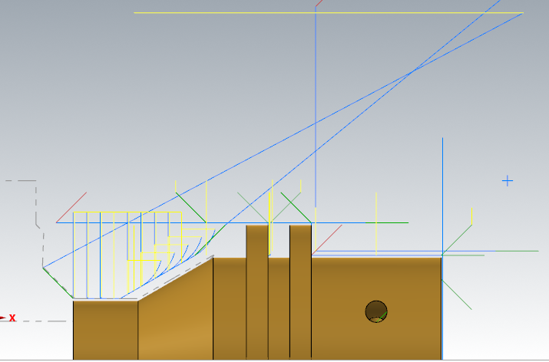~~

Figure 4‑9: Inner element of the swirler

The outer element was machined using a CNC lathe. The first process was facing. This was followed by a rough turning operation on the profile. A grooving tool was then used to machine the end on the profile where there is a diameter change. The outer element was then finalized with a finishing turning operation. For the internal profile, a drill of diameter 8 is passed through the entire stock. This is followed by drilling with a 12 mm drill to a depth of 12.12mm. The internal profile is then finalized by an internal turning operation. The part was then cut off from the stock using a grooving tool. The holes were machined using a 5 axis milling machine.

~~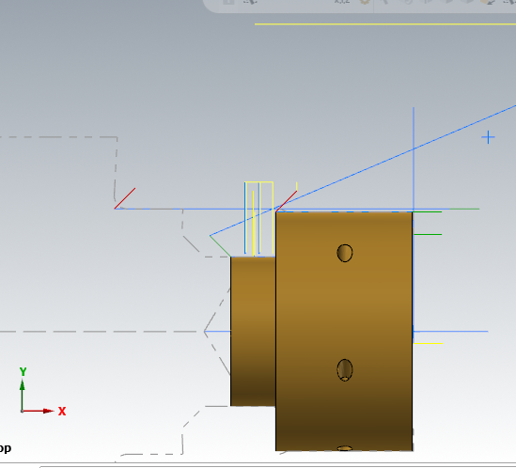~~

Figure 4‑10: Outer element of the swirler

##### Baseplate

The stock of this part was as defined:

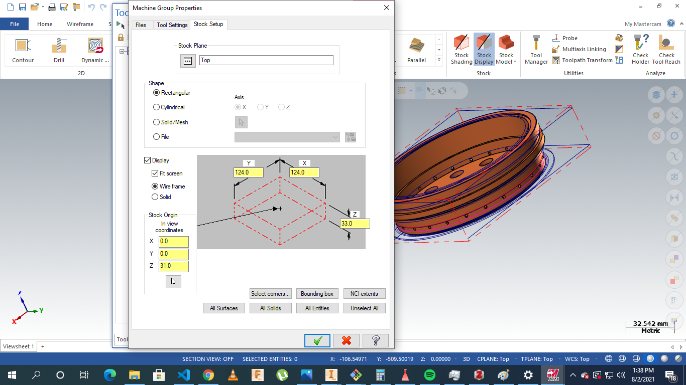

Figure 4‑11: Base plate machining

The operations were to be conducted on five-axis milling. The processes involved include facing, contour milling drilling slot milling, and multi-axis drilling.

The parts were milled as the material to be used was brass.

Operations are highlighted below:

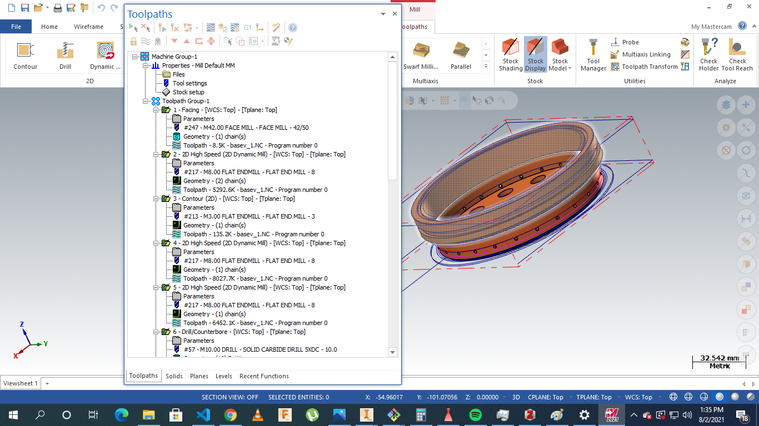

Figure 4‑12: Base Plate total operations

##### Separator plate

The stock was as defined:

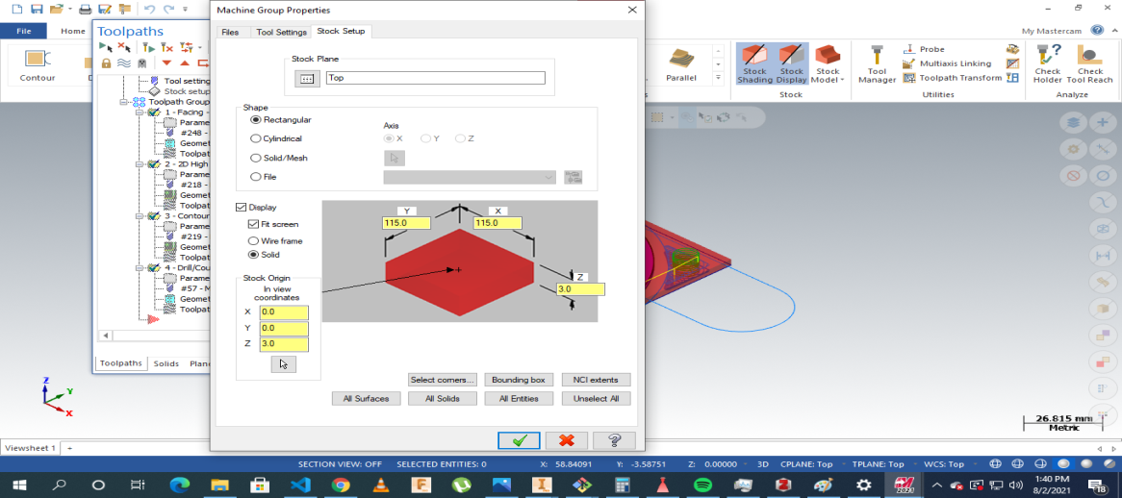

Figure 4‑13: Separator Plate Stock setup

The operations involved: facing, drilling,contouring, and parting.

The processes were as displayed

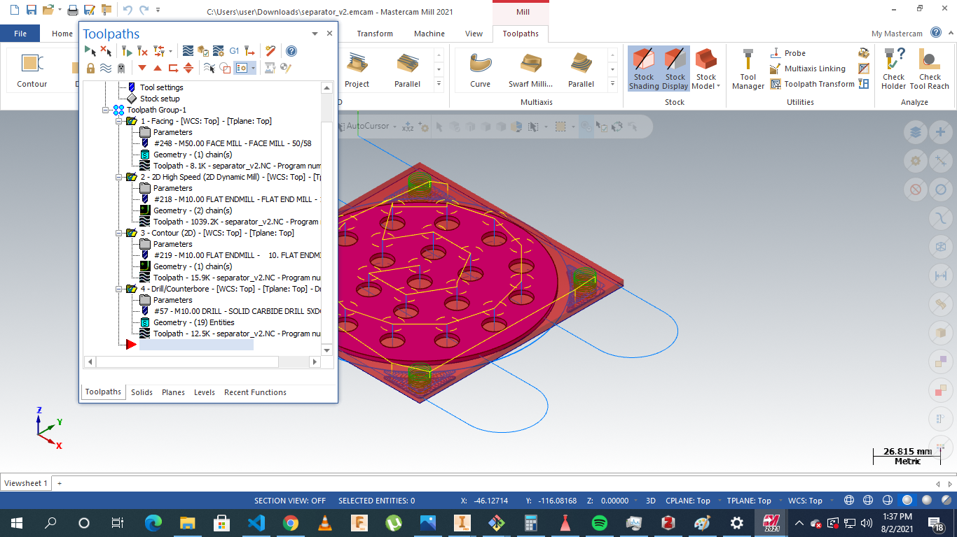

Figure ‑: Stock Plate Machining Instructions

### Assembly

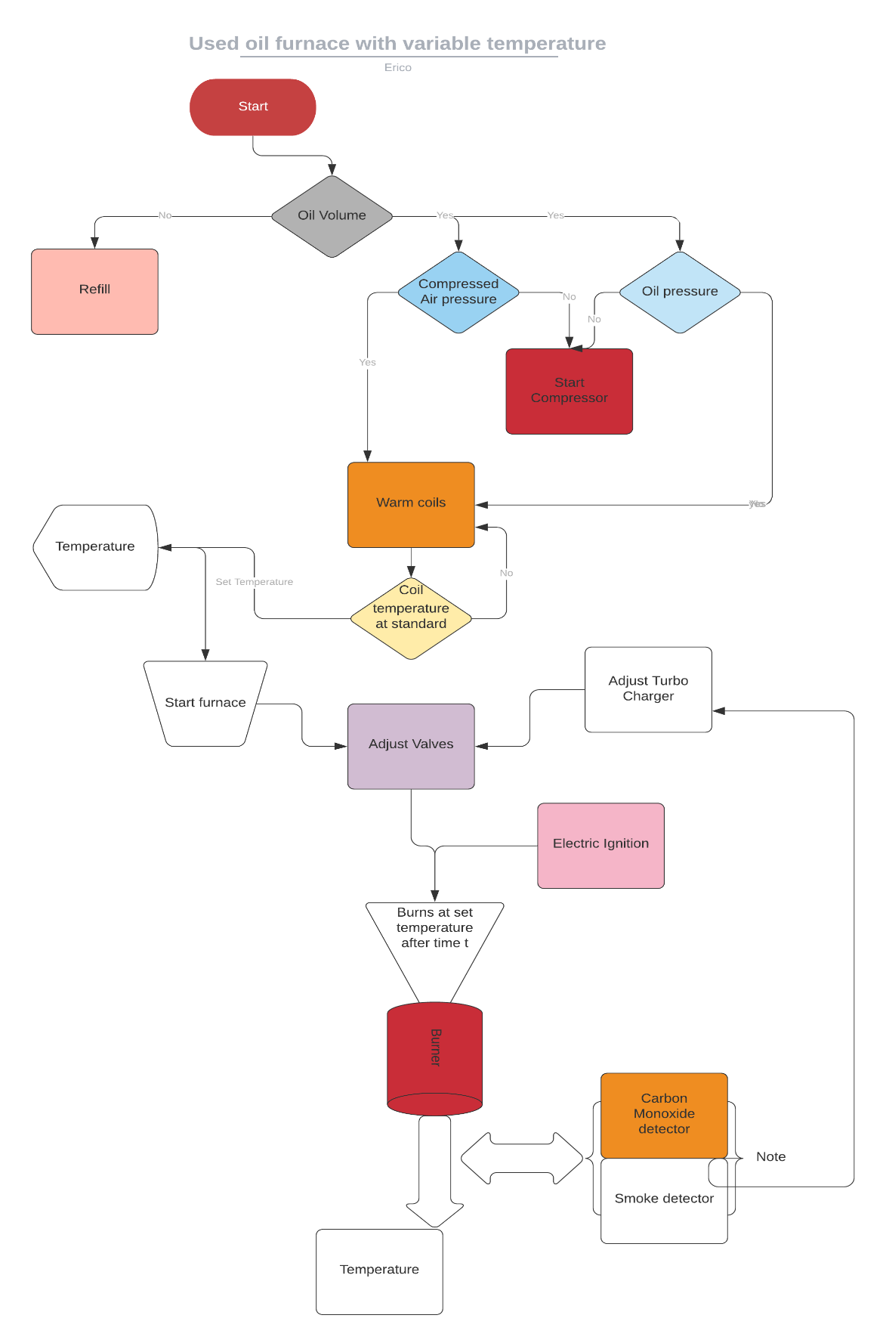

Figure 4‑15: Process flow chart

#### Working principle

On powering on, the system automatically checks the volume of oil in the oil storage tank. This is determined by a **level sensor** installed in the tank. Depending on the volume, the system decides whether to refill the tank from an even bigger tank or raise an alert for a refill. If the required volume of oil is available the system then checks the pressure of oil in the tank and the pressure of compressed air in the air storage tank using **pressure sensors**. In any case, the pressure is below the required, the system automatically turns on the compressor to refill the two containers to the required pressure. Once the pressure requirements in the two containers are met, the system automatically switches off the compressors and starts warming the **coils** on the path of the pressurized oil to the injector. The compressor is turned on, and off to maintain constant pressure in the tank.

Once the coils warm to a standard base temperature, the user is then prompted on the interface to enter the **furnace operation temperature**. From this input, the system adjusts both the air and pressurized oil valves using **a stepper motor** connected to each of this valves. A supercharger is connected to the compressed air flow pipe through a **pneumatic motor** and a **pneumaticgear system** to magnify the speed of the airflow. It is also adjusted in proportion to the pressure along the airflow pipe. This is to ensure the maximum supply of oxygen to the combustion chamber and to reduce emissions.

The pressurized oil and compressed air mix evenly in the **coaxial swirl injector**. The injector is designed in such a way that it ensures oil is atomized and mixes evenly with enough amounts of oxygen. Once the flow of oil and pressurized air is steady, an **electric igniter** descends to the tip of the nozzle and sparks to ignite the mixture. It then retracts to a safer height since its material cannot withstand furnace temperatures.

The mixture burns at the burner. With the use of silicon carbide as the burner material, the burner can achieve up to **18340C.** Around the burner are the **smoke detector**, **carbon monoxide detector, and a thermal gun**. These sensors continuously check the smoke, levels of carbon monoxide, and temperature at the output, and this information is transferred to the ECU which adjusts the supercharger, oil, and air valves to correct the values.

# Chapter 5

## CONCLUSION

Therefore based on the design results obtained from the design calculations in tandem with incorporating Mechatronic approach to the design of the used oil furnace with temperature variables, the set objectives for instance automation of the oil and pressure flow, ignition and temperature. We managed to design preheating coils that could not only withstand very high temperature due to choice of nickel and chromium but also with minimal pitch to ensure efficient heat transfer. Besides, the choice of carbon fibre on the high pressure tank with the maximum permissible thickness ensured that it could sustain maximum possible compressed air and so was with the case of the burner and the coaxial swirl injector. It is from the above considerations that the following conclusions can be made.

1. Incorporating a Mechatronic approach in the design of the used oil furnace with temperature variable will greatly improve the efficiency of the system and a the same time reduce on the risks such as explosions and health hazards.

# References

[L.-J. Yang and Q.-F. Fu, ‘Theoretical Investigation on the Dynamics of a Gas-Liquid Coaxial Swirl Injector’, *J. Propuls. Power*, vol. 27, no. 1, pp. 144–150, 2011.](https://www.zotero.org/google-docs/?tOBzsF)

H. Belal, A. Makled, and M. Al-Sanabawy, “Vaporization-controlled simplified model for liquid propellant rocket engine combustion chamber design,” IOP Conference Series: Materials Science and Engineering, vol. 610, p. 012088, Oct. 2019, doi: 10.1088/1757-899X/610/1/012088.

Edge, E. (2021). Clavarinos equation thick-walled cylinders of ductile material Calculator and formula. Retrieved 7 August 2021, from [https://www.engineersedge.com/calculators/cl avarinos equation_thickwalled_cylinders_15620.htm](https://www.engineersedge.com/calculators/cl%20avarinos%20equation_thickwalled_cylinders_15620.htm)